**Feature List and User Journey for Sports Equipment eCommerce Portal**

**Purpose of the Document**:  
Aims to develop an e-commerce platform for sports equipment, focusing on delivering an exceptional product experience for customers while ensuring a seamless onboarding process for vendors joining the platform.

### **2. Objective**

* To design an eCommerce platform for sports equipment.
* Ensure smooth customer experience and vendor onboarding processes.

### **3. Assumptions**

* The platform will support multiple payment methods.
* Vendors will manage their inventory independently.

### **4. Feature List**

**For Customers**:

1. Visit the website or download the app.
2. **Sign-Up**:
   * Enter email or phone number and create a password.
   * Verify account via OTP or email link.
3. **Profile Setup**:
   * Add delivery address, preferences, and payment options (optional).
4. **Browse Products**:
   * Search or explore categories.
5. **Add to Cart**:
   * Select items and proceed to checkout.
6. **Payment**:
   * Choose payment method and confirm purchase.
7. **Post-Purchase**:
   * Track order, provide reviews, and contact support if needed.

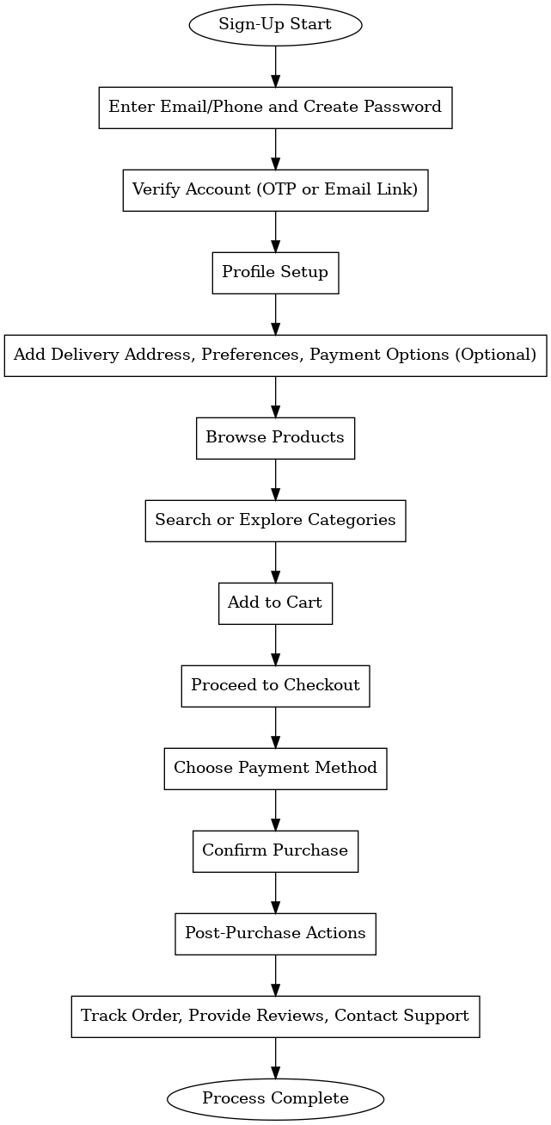

**For Vendors**:

1. Visit the vendor registration portal.
2. **Sign-Up**:
   * Provide basic details (name, email, phone number).
   * Upload business documents (GST, PAN, etc.).
3. **Verification**:
   * Admin reviews documents and approves the account.
4. **Profile Setup**:
   * Add business details (store name, logo, description).
5. **Product Listing**:
   * Add products with images, descriptions, and prices.
6. **Start Selling**:
   * Manage orders and monitor sales using the dashboard.

#### 

#### 

#### 

